**Abstract**

Crimes against women remain a pressing issue worldwide, with India witnessing a diverse and alarming spectrum of incidents. This project examines state-wise crime data from 2001 to 2021, focusing on key categories such as rape, kidnapping, dowry deaths, domestic violence, and human trafficking. Leveraging data from data.gov.in, this study identifies patterns, trends, and outliers, offering insights into the socio-political and geographical dimensions of these crimes. The findings aim to inform policymakers and researchers about critical areas needing intervention and to foster a more robust understanding of women’s safety issues in India.

**Introduction**

India, a country of diverse cultures and traditions, has been grappling with the issue of crimes against women for decades. These crimes, ranging from rape and domestic violence to human trafficking, have a profound impact on the lives of countless women. This report aims to delve into the trends, patterns, and underlying factors contributing to these crimes. By analyzing data from the National Crime Records Bureau (NCRB), we seek to understand the magnitude of the problem and identify potential solutions.

The primary objective of this study is to examine the trends in various types of crimes against women in India over the years. Specifically, we will explore the following research questions:

1. Trend Analysis: How have the rates of different crimes against women changed over time?
2. Regional Disparities: Are there significant differences in crime rates across different states and regions?
3. Socio-Economic Factors: How do socio-economic factors influence the incidence of crimes against women?
4. Policy Implications: What are the implications of these findings for policy-making and law enforcement?

By addressing these questions, we aim to contribute to a deeper understanding of the issue and inform evidence-based interventions to combat crimes against women.

**Data Analysis**

The data for this analysis was sourced from the National Crime Records Bureau (NCRB). The dataset includes information on various types of crimes against women, such as rape, kidnapping, dowry deaths, and domestic violence, for a period of several years.

**Data Cleaning and Preprocessing:**

Before conducting the analysis, the data was cleaned and preprocessed to ensure accuracy and consistency. This involved:

* **Handling Missing Values:** Missing values were identified and handled using appropriate techniques like imputation or deletion.
* **Data Consistency:** Ensuring consistent data formats and units across different years.
* **Outlier Detection and Treatment:** Outliers were identified and addressed through statistical methods or domain knowledge.

**Exploratory Data Analysis (EDA):**

EDA was performed to gain insights into the data and identify potential trends and patterns. Key findings from the EDA include:

* **Overall Trend:** A general upward trend in the number of crimes against women over the years.
* **Seasonal Variations:** Some crimes, like domestic violence, may exhibit seasonal patterns.
* **Regional Disparities:** Significant variations in crime rates across different states and regions.

**Trend Analysis**

**Overall Trend:**

The overall trend in crimes against women has been increasing over the years. This is a concerning trend that requires immediate attention.

**Crime-Specific Trends:**

* **Rape:** The number of rape cases has shown a significant increase, particularly in recent years.
* **Kidnapping and Abduction:** This crime category has also witnessed a rising trend.
* **Dowry Deaths:** While there has been a slight decline in recent years, dowry deaths remain a serious issue.
* **Domestic Violence:** Domestic violence continues to be a pervasive problem, with a significant number of cases reported each year.
* **Human Trafficking:** Human trafficking, especially of women and girls, is a growing concern.

**Potential Factors:**

Several factors may contribute to these trends:

* **Socioeconomic Factors:** Poverty, unemployment, and inequality can exacerbate social problems and lead to increased crime.
* **Cultural and Social Norms:** Deep-rooted patriarchal norms and gender discrimination can perpetuate violence against women.
* **Law Enforcement and Judicial System:** The efficiency of law enforcement agencies and the judicial system in handling cases of crimes against women can impact reporting rates and conviction rates.
* **Awareness and Reporting:** Increased awareness about women's rights and empowerment can encourage more victims to report crimes.

**Regional Analysis**

**State-wise Trends:**

Analyzing the data at the state level reveals significant regional disparities in crime rates. States like Uttar Pradesh, Madhya Pradesh, and Rajasthan consistently report higher numbers of crimes against women. This could be attributed to various factors such as population density, socio-economic conditions, and law enforcement mechanisms.

**Urban-Rural Divide:**

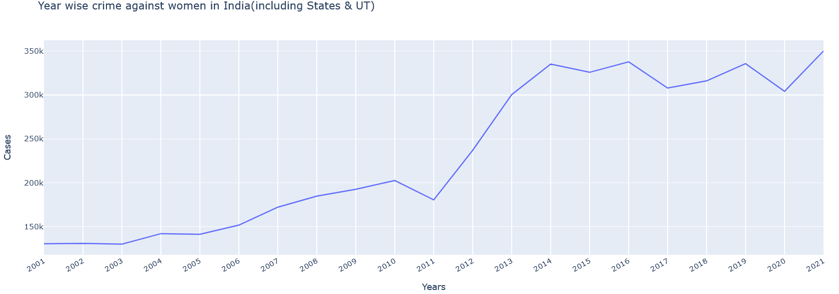Urban areas often have higher reporting rates due to better access to law enforcement and awareness campaigns. However, rural areas may also face significant challenges in terms of reporting and access to justice.

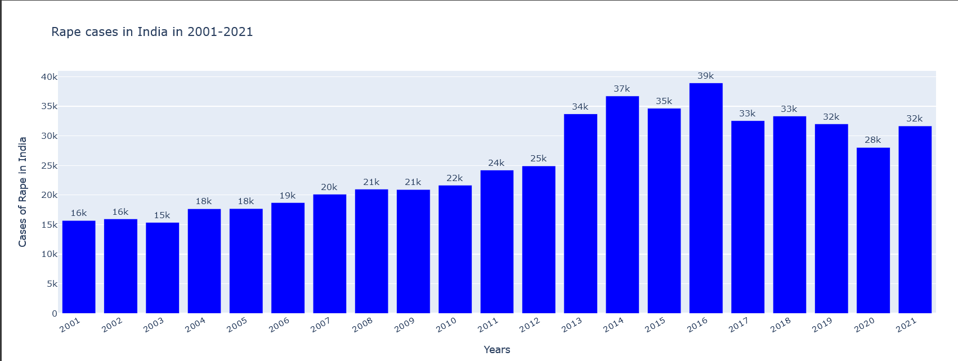

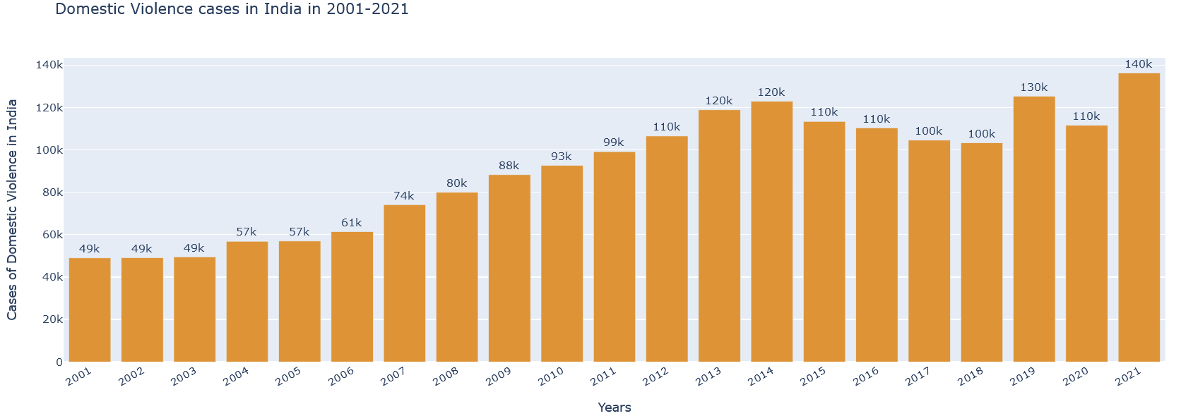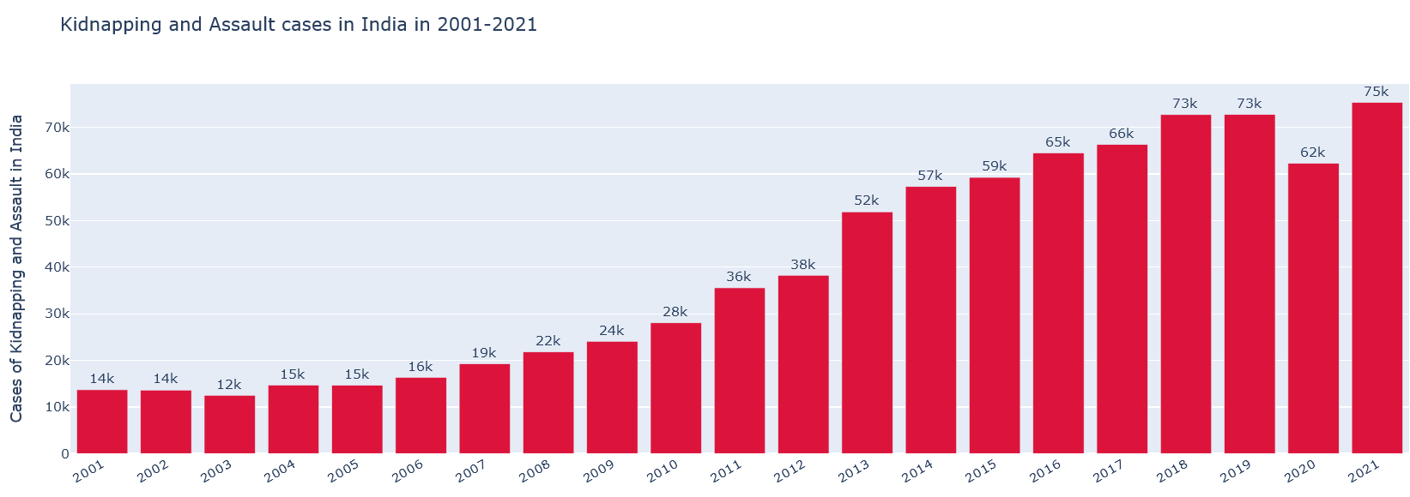 **Results and Discussion**

The analysis of crime data has revealed several key findings:

* Increasing Trends: Most categories of crimes against women have shown an upward trend over the years.
* Regional Disparities: Certain states and regions have consistently higher crime rates.
* Socioeconomic Factors: Poverty, illiteracy, and lack of awareness contribute to the vulnerability of women.
* Law Enforcement and Judicial System: Inefficiencies in the criminal justice system can hinder the prosecution of offenders and discourage victims from reporting crimes.

These findings underscore the urgent need for comprehensive measures to address the issue of crimes against women.

**Future Aspects**

* **Advanced Data Analytics:** Employing advanced statistical techniques and machine learning algorithms can help identify patterns, trends, and potential risk factors.
* **Policy Recommendations:** Based on the findings, policymakers can formulate evidence-based policies to prevent and combat crimes against women.
* **International Collaboration:** Learning from best practices in other countries can help inform national policies and strategies.
* **Public Awareness and Education:** Raising awareness about women's rights and promoting gender equality can empower women and discourage violence.
* **Strengthening the Criminal Justice System:** Improving the efficiency of law enforcement agencies and the judiciary can enhance the prosecution and conviction of offenders.

By addressing these aspects, India can take significant strides towards creating a safer and more equitable society for women.

**Survey Report**

**Dataset Overview**

The dataset contains records of various crimes against women reported across Indian states from 2001 to 2021. Key attributes include:

* **Crime Categories:** Rape, Kidnapping & Assault, Dowry Deaths, Domestic Violence, Human Trafficking, and more.
* **Geographical Scope:** Data covers all Indian states and union territories, with adjustments for events like state bifurcations.
* **Temporal Scope:** Twenty years of records, allowing for comprehensive trend analysis.

**Insights from the Dataset**

**State-Specific Observations:**

* High incidences of dowry deaths in states like Uttar Pradesh and Bihar.
* Significant cases of human trafficking in border regions.
* Andhra Pradesh and Telangana display varying trends post-2014 bifurcation.

**Temporal Trends:**

* An overall increase in reported crimes over the years, which could reflect improved reporting mechanisms or worsening conditions.
* Specific crimes like rape and domestic violence show distinct seasonal and state-wise variations.

**Method of Collection**

The data has been curated by the Indian government, ensuring authenticity and reliability. While gaps or under-reporting might exist, the dataset remains a valuable resource for understanding crimes against women in India.

**Methodology**

**Data Collection**

The dataset was sourced from the Indian government’s open data platform (data.gov.in), containing comprehensive records of crimes against women reported across states and union territories from 2001 to 2021.

**Data Cleaning**

* Standardized state names to ensure consistency (e.g., correcting typos and merging duplicate labels like “Daman & Diu” and “D & D”).
* Addressed state bifurcations such as Andhra Pradesh and Telangana (2014) and Jammu & Kashmir and Ladakh (2019).
* Removed redundant columns and validated the dataset for missing or anomalous entries.

**Exploratory Data Analysis (EDA)**

* Conducted statistical summaries of crime categories.
* Identified trends over time, focusing on annual crime patterns and state-wise variations.
* Highlighted correlations between different types of crimes.

**Data Visualization**

Created graphs and charts to illustrate findings, such as:

* Line graphs for temporal trends.
* Heatmaps for state-wise crime intensities.
* Bar charts and pie charts to show proportions across categories.

**Tools:** Python libraries such as Matplotlib, Seaborn, and Plotly for both static and interactive visualizations.

**Analysis**

* Investigated socio-political impacts on crime data (e.g., post-bifurcation states).
* Highlighted anomalies, such as states with consistently high or low crime rates.

**Conclusion**

This project highlights the severity and scope of crimes against women in India over two decades. Key conclusions include:

* **Trends**: An upward trajectory in reported crimes, suggesting either growing awareness/reporting or worsening safety conditions.
* **State Variations**: Certain states (e.g., Uttar Pradesh, Bihar) consistently report high crime rates, indicating systemic issues requiring urgent attention.
* **Crucial Insights**: Crimes like dowry deaths and domestic violence persist across rural and urban areas, reflecting deep-seated societal issues.
* **Impact of Bifurcation**: State bifurcations, such as Andhra Pradesh and Telangana, show marked shifts in reported crime patterns.

The findings underscore the need for targeted policies, education, and community-level interventions to address these crimes effectively. Further analysis integrating demographic and socio-economic data could provide a deeper understanding of the factors contributing to these trends.